# Phase-End Project 3

# Non-Functional Testing Using Postman, REST Assured, and

# JMeter

**Project Agenda:** To automate functionalities using https://petstore.swagger.io/ REST API services

**Scenario:**

You are working as a Test Engineer in XYZ Corp. Your company has decided to automate a few

functionalities for one of the Pet Store companies.

You have been asked to design an end-to-end functionality to automate three REST API services

using Postman and Rest Assured.

**Tools Required:**

● Postman

● Java 1.8+

● Maven

● Rest Assured Maven dependency version 4.5.1

● TestNG Maven dependency version 7.1.0

● Maven dependency

● Newman for Postman

● Jmeter

**Postman:**

**Assignment 1 to 5:**

**Screenshots of code output of assignment 1 to 5:**

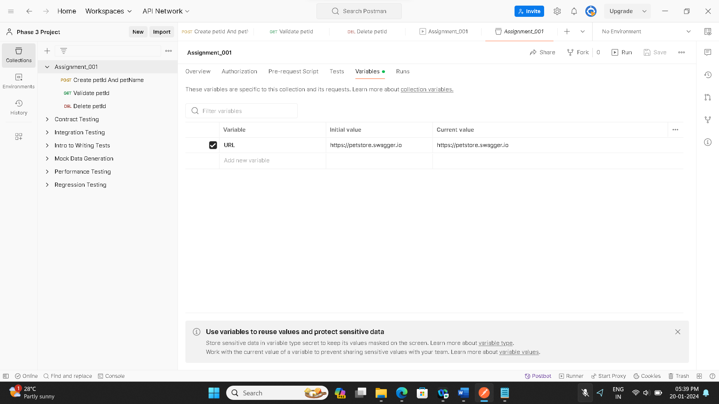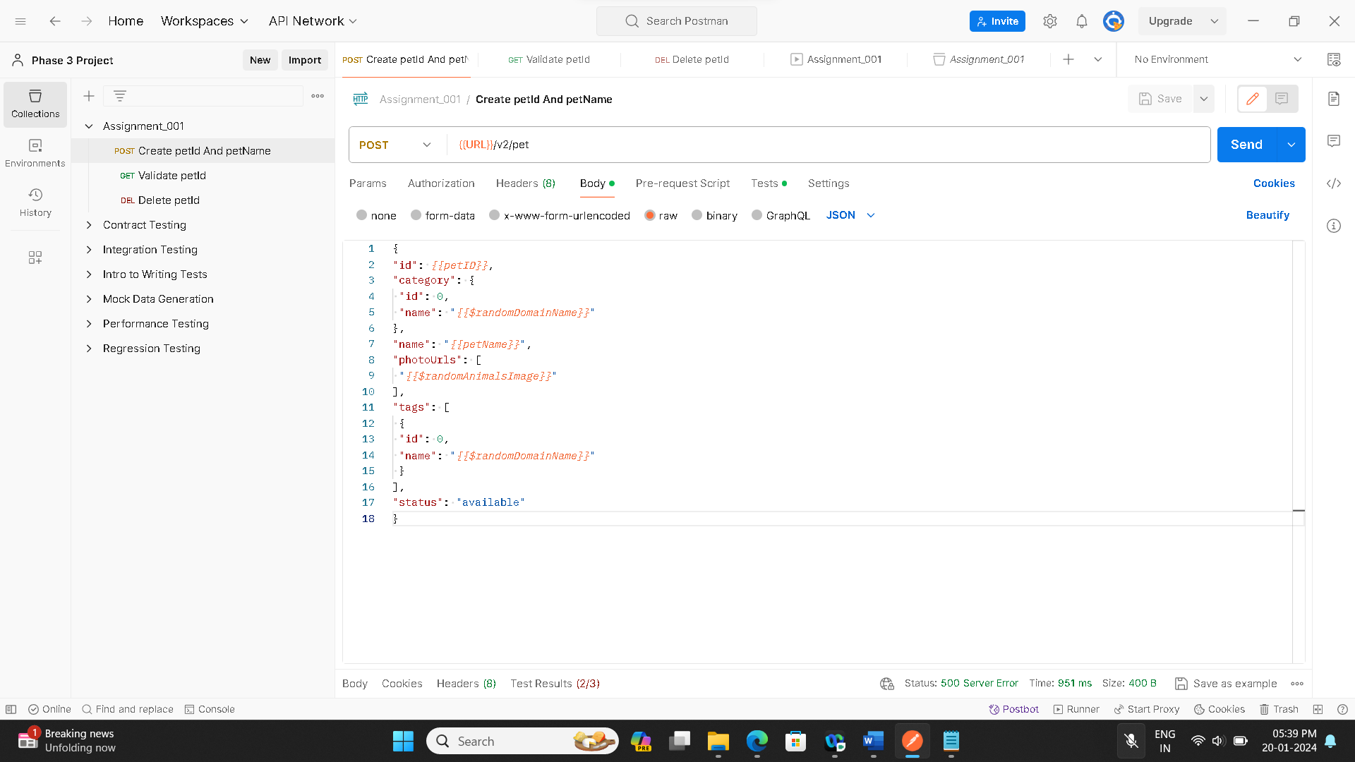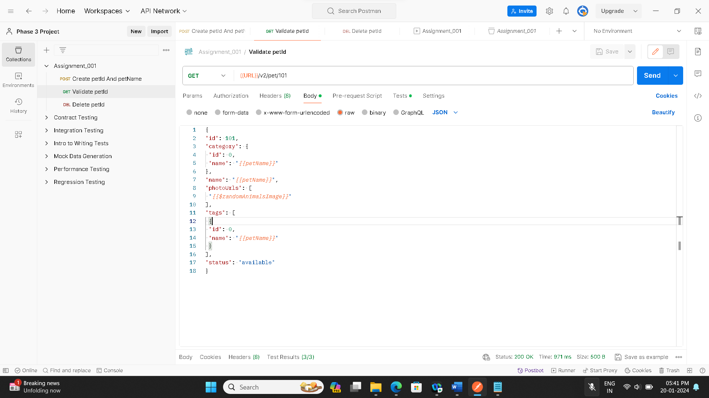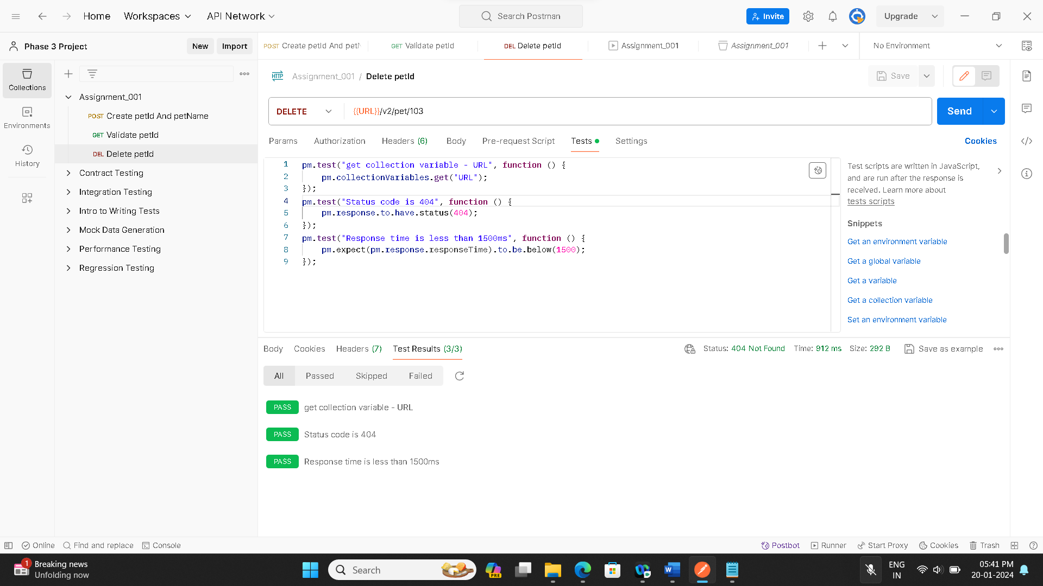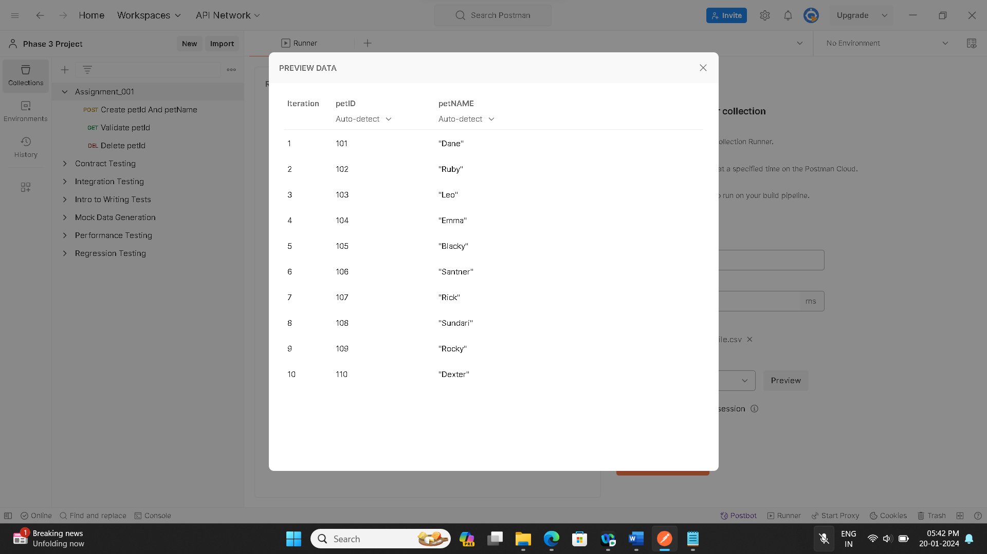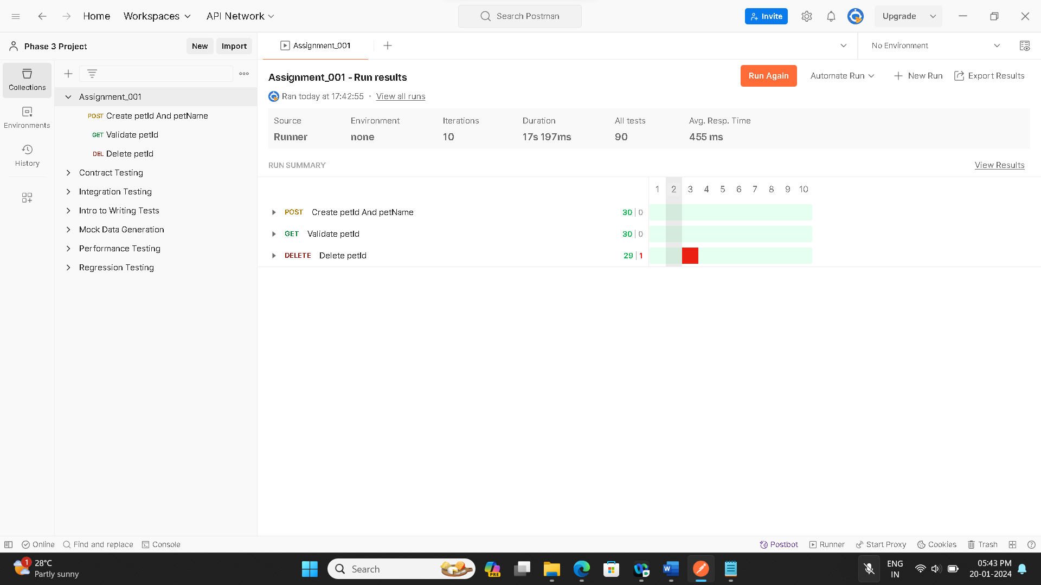

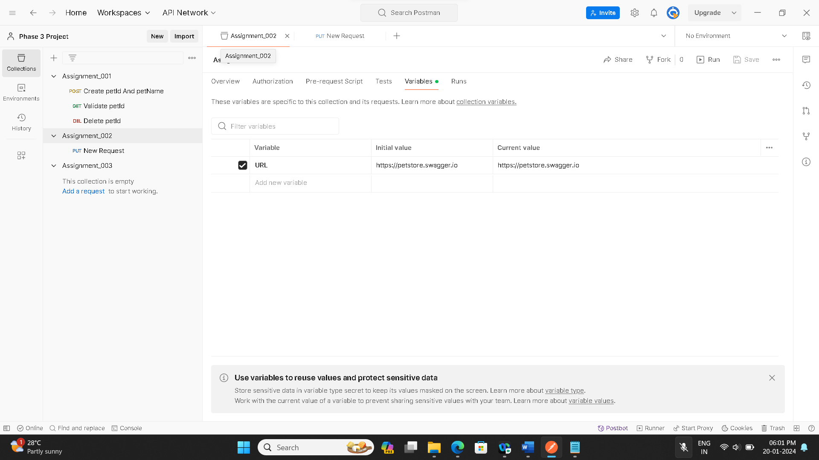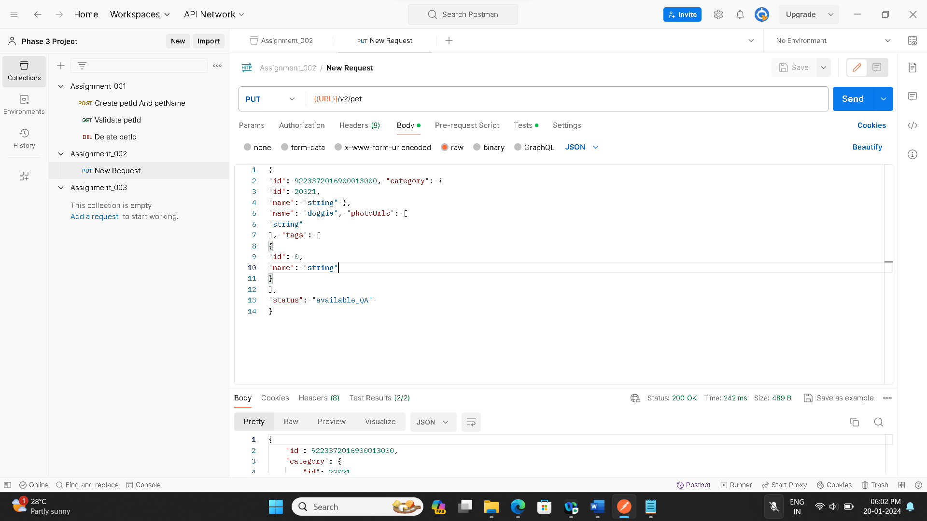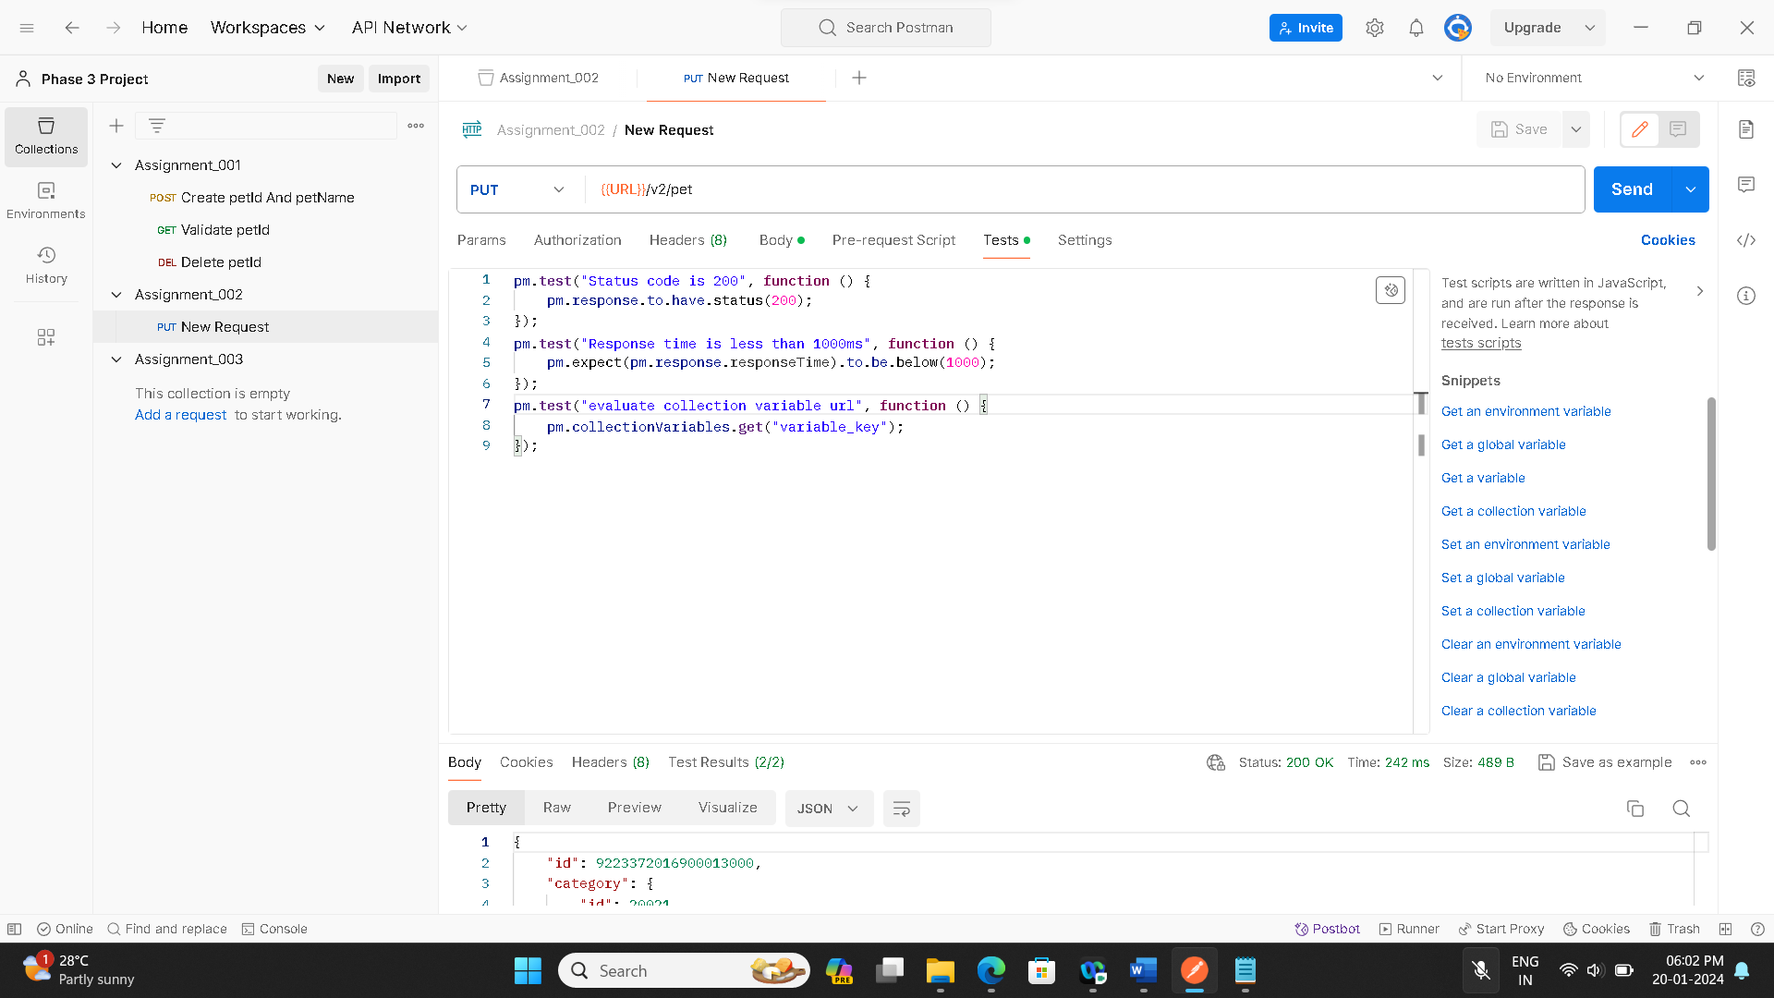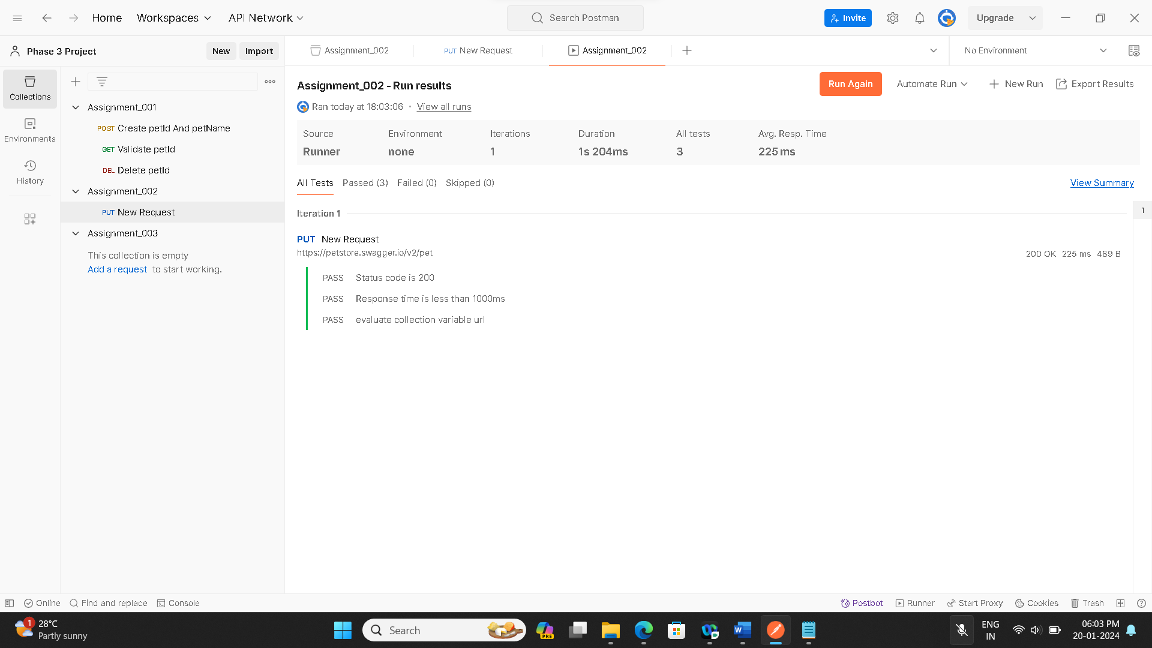

**Jmeter :**

● Validate https://httpbin.org/basic-auth/user/passwd link using HTTP Authentication

manager

● Default username is user, and the default password is passwd

● Validate response is a JSON file using JSON assertion

● Using HTTP sampler, hit https://www.simplilearn.com and validate xpath as //img[@title='Simplilearn - Online Certification Training Course Provider']

● Increase the thread count and do lead testing

**Screenshots of code, output:**

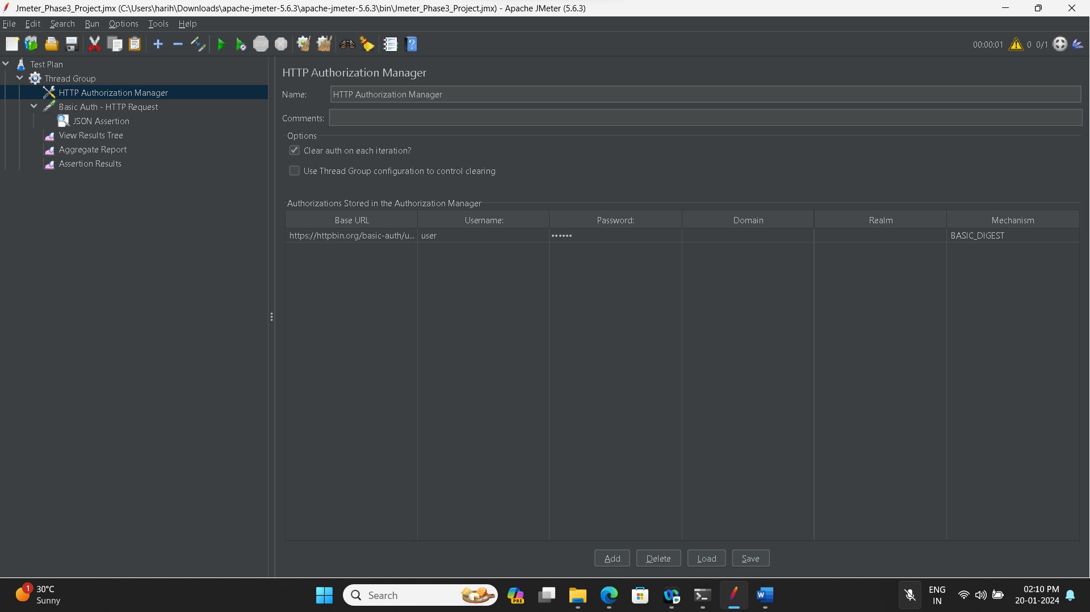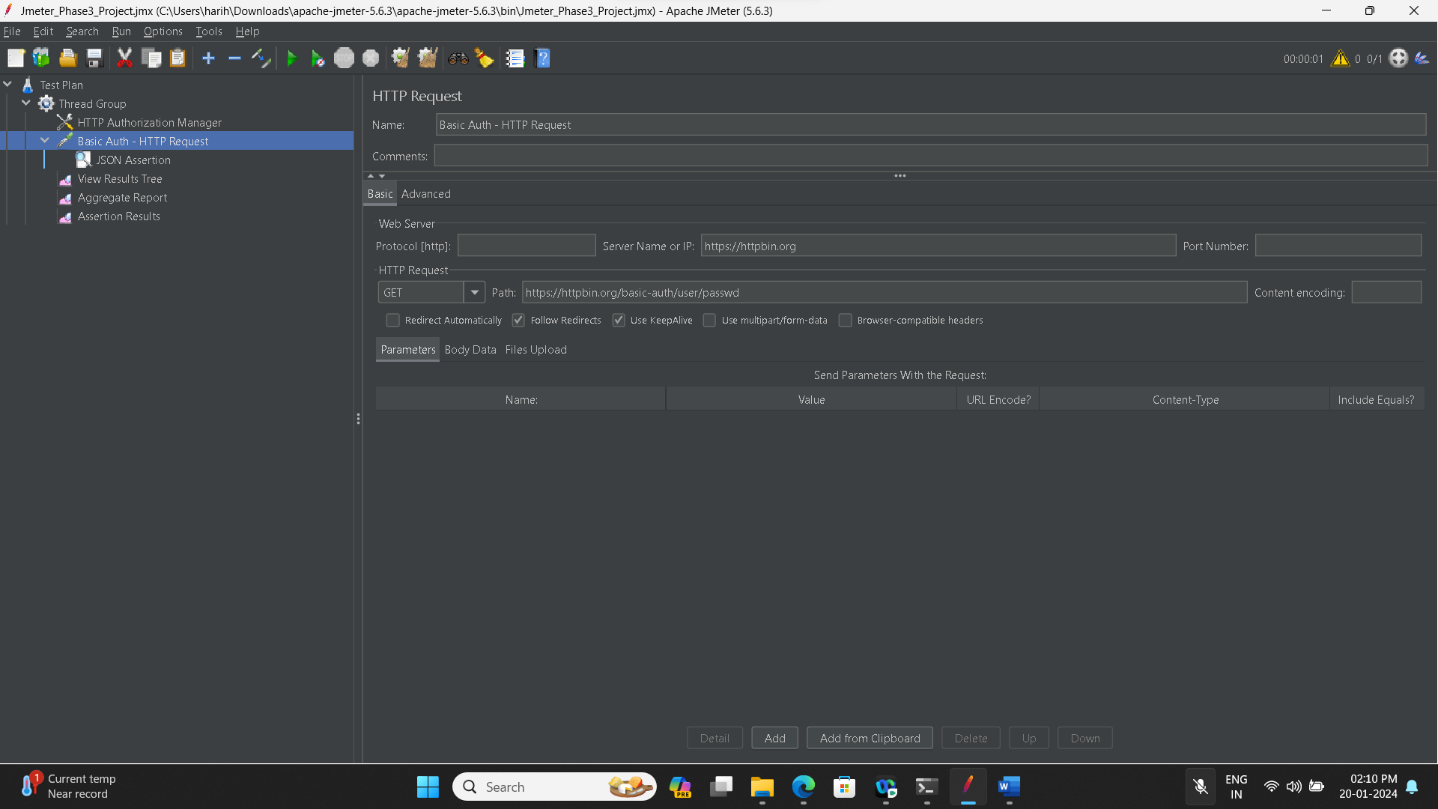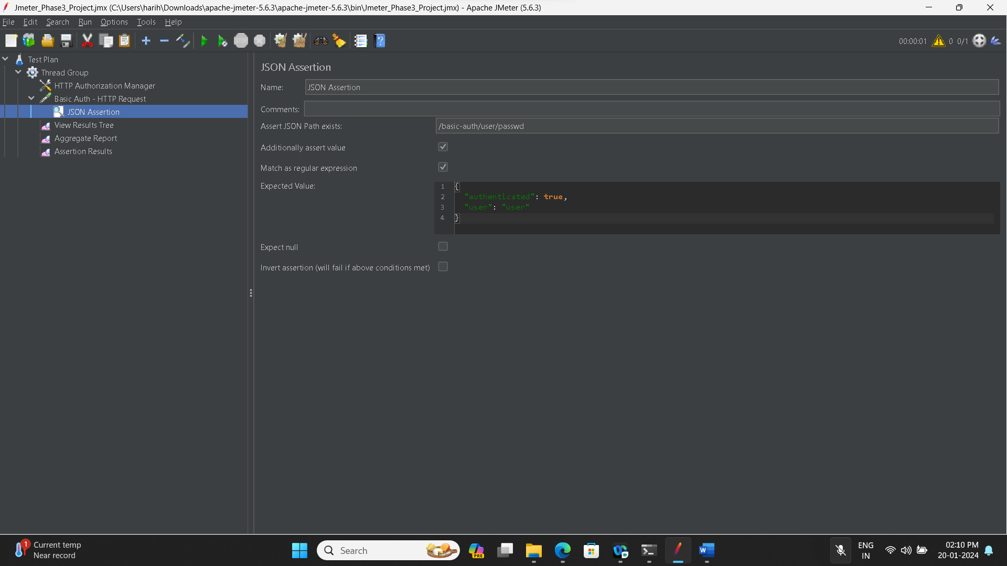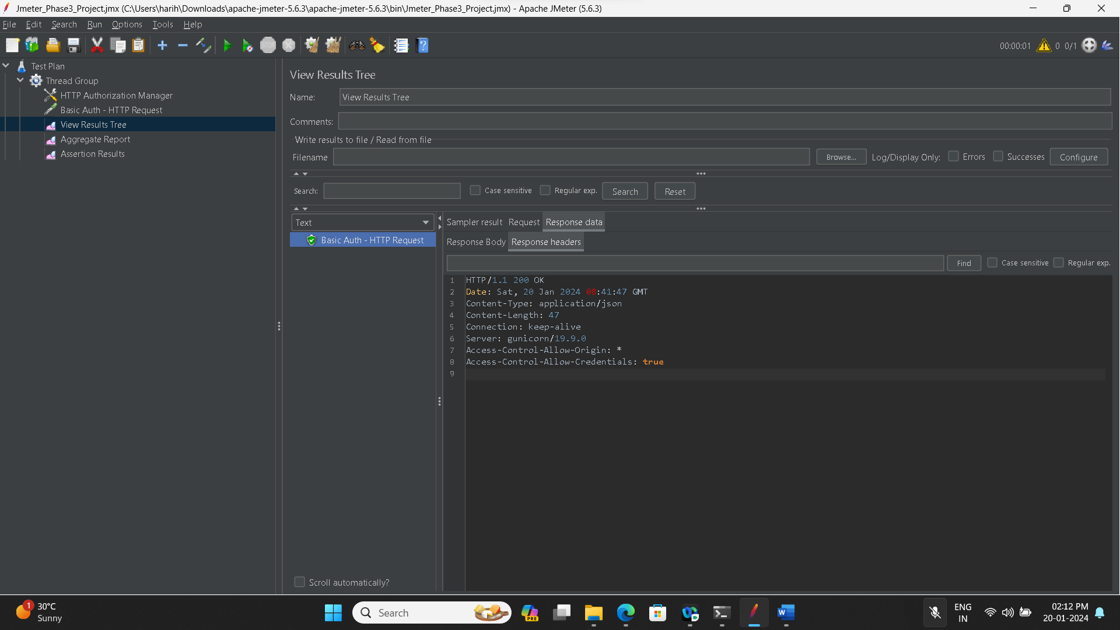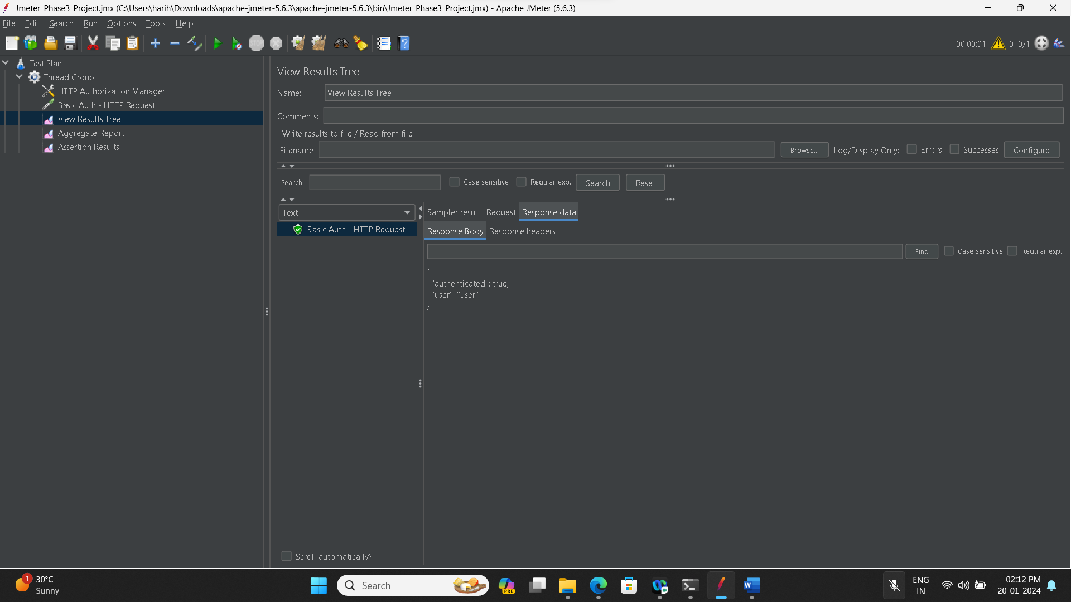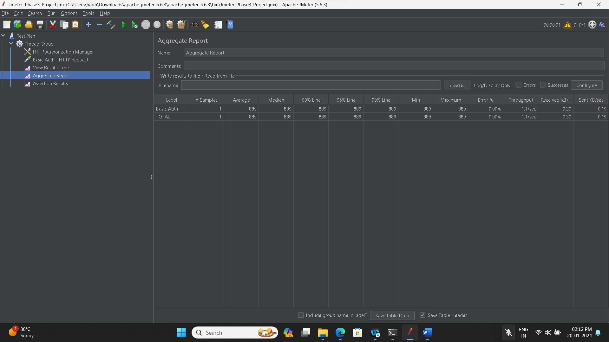

**Restful Api:**

 